

NOTRE DAME UNIVERSITY
BANGLADESH
CSE LAB Report-02
Submitted by:
Name: Istiak Alam
ID: 0692230005101005
Batch: CSE-20
Date: 23-07-23
Course Title: Data Structure Lab
Course Code: CSE-2104
Lab Task Topic: Array Insert, Delete & Sorting.

Submitted To:
Humayara Binte Rashid
Lecturer, NDUB

Problem No. 01
Name of the problem: Write a program in C to insert an element in an array.

Solution:
//Lab 2 task 1
// Insert an element
#include <stdio.h>
int main()
{
int n, i, l, item;
printf("Enter your array size:");
scanf("%d", &n);
printf("Enter Array elements:");
int array[n];
for (i = 1; i <= n; i++)
{
scanf("%d", &array[i]);
}
printf("Enter the element to be inserted in the array: ");
scanf("%d", &item);
printf("Enter the location where the element %d is to be inserted: ", item);
scanf("%d", &l);
if (l <= n)
{
int j;
for (j = n; j >= l; j--)
{
array[j + 1] = array[j];
}
array[l] = item;
n = n + 1;
}
else
printf("The entered location is out of bound.");
printf("\nModified Array: ");
for (i = 1; i <=n; i++)
printf("%d ", array[i]);
printf("\n");
}

Output:

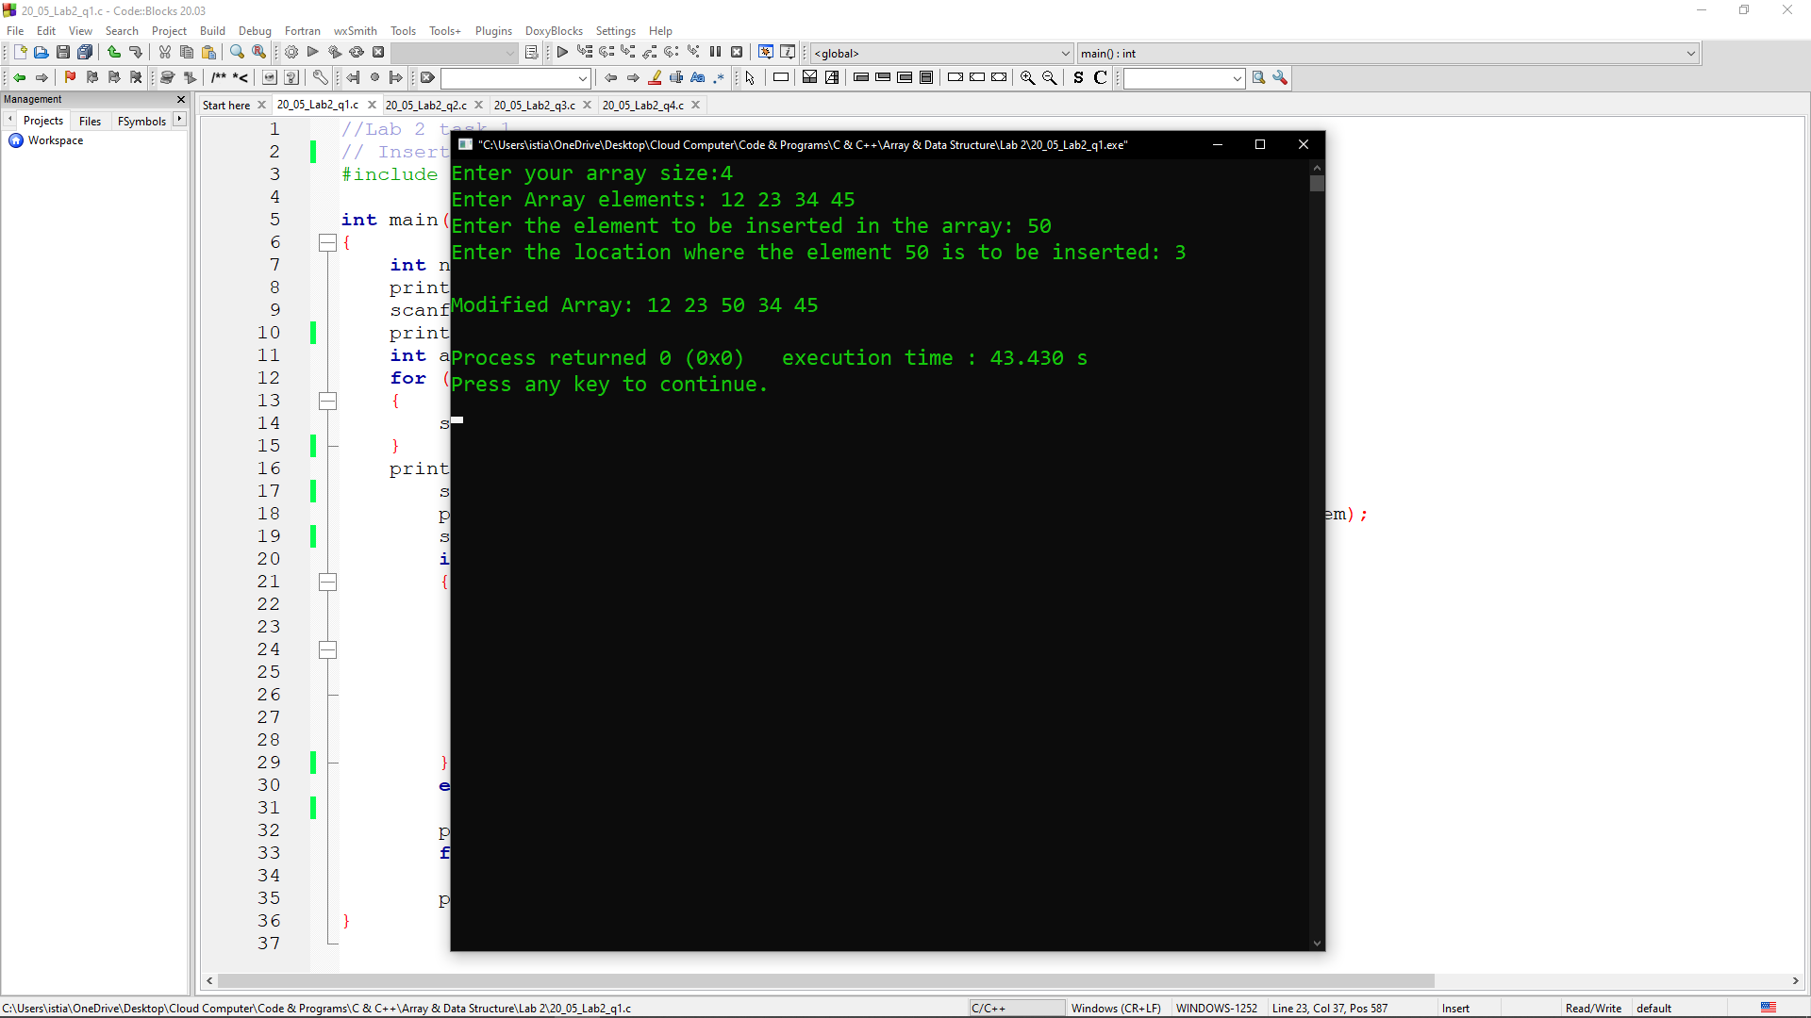

Problem No. 02
Name of the problem: Write a program in C to delete an element in an array.

Solution:
//Lab 2 task 2
// delete element
#include <stdio.h>
int main()
{
int n, i, l, item;
printf("Enter your array size:");
scanf("%d", &n);
printf("Enter Array elements:");
int array[n];
for (i = 1; i <= n; i++)
{
scanf("%d", &array[i]);
}
printf("\nEnter the location from where element is to be deleted: ");
scanf("%d", &l);
if (l <= n)
{
int j;
item = array[l];
printf("\nItem %d deleted from location %d\n", item, l);
for (j = l ; j < n ; j++)
{
array[j] = array[j + 1];
}
n = n - 1;
}
else
{
printf("\nThe Entered location is out of bound.");
}
printf("Modified array: \n");
for (i = 1; i <= n; i++)
{
printf("A[%d] = %d \n",i, array[i]);
}
printf("\n");
}

Output:
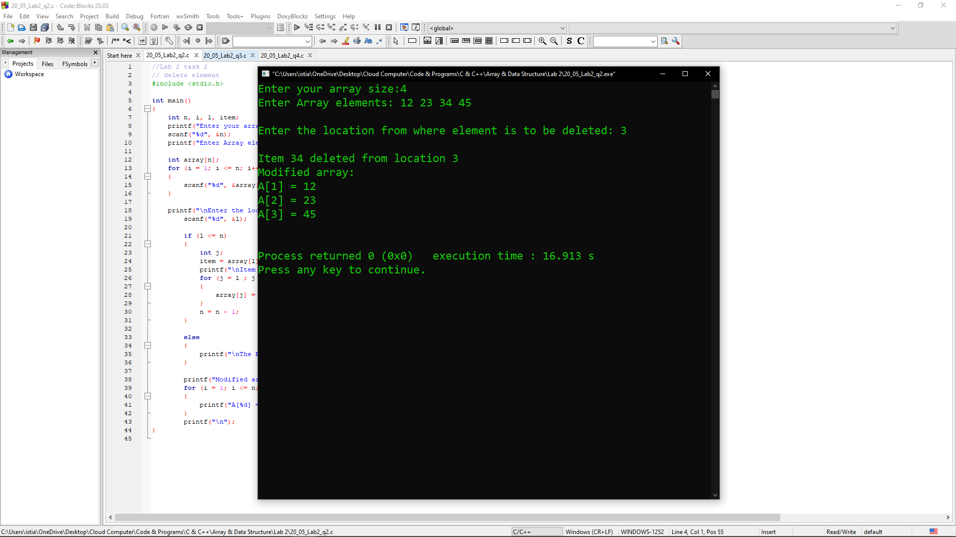

Problem No. 03
Name of the problem: Write a program in C to Sort a number of students by using their heights in an array.

Solution:
// Lab 2 task 3
// sort element
#include <stdio.h>
int main()
{
int n, i, j;
float t;

printf("Number of Students : ");
scanf("%d", &n);
printf("Heights : ");
float array[n];
for (i = 0; i < n; i++)
{
scanf("%f", &array[i]);
}

for (i = 0 ; i < n - 1; i++)
{
for (j = 0 ; j < n - i - 1; j++)
{
if (array[j] > array[j+1])
{
/* Swapping */
t = array[j];
array[j] = array[j+1];
array[j+1] = t;
}
}
}
printf("Sorted height: ");
for (i = 0; i < n; i++)
{
printf("%.2f ", array[i]);
}
}

Output:
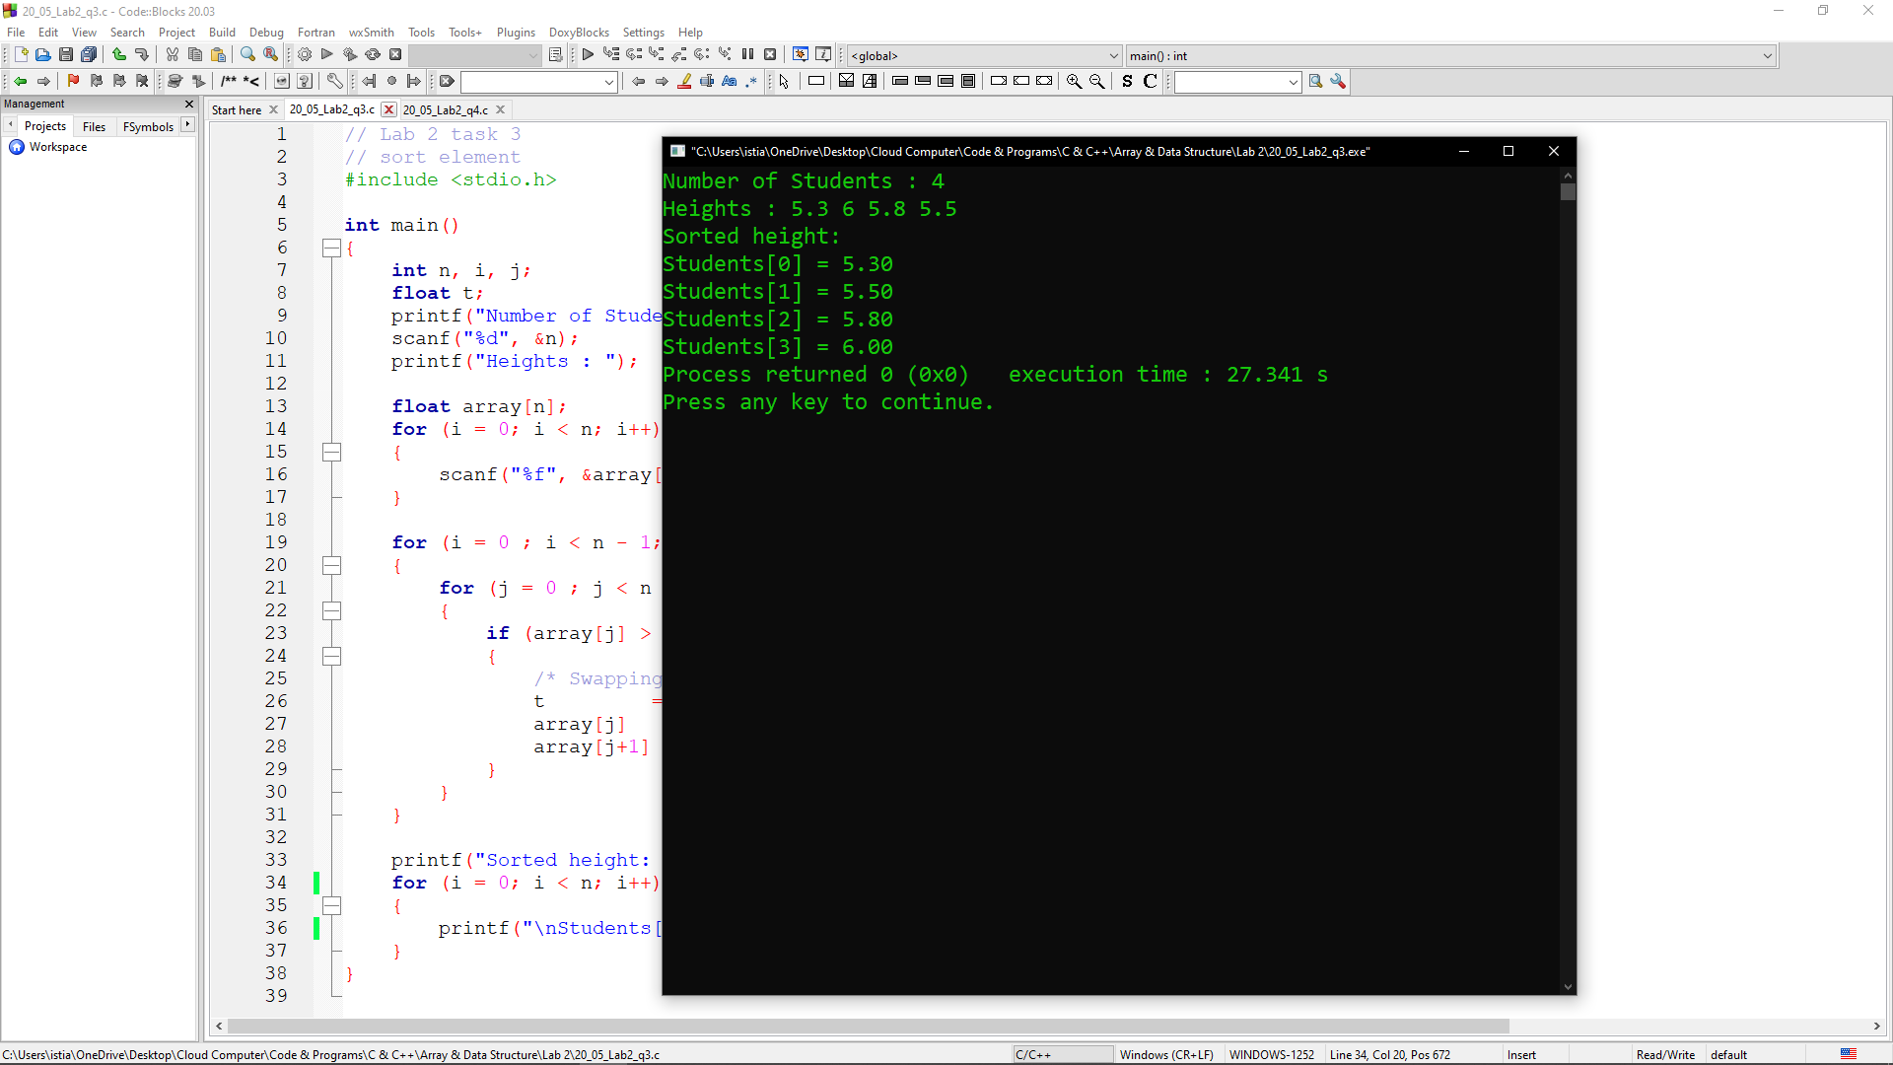

Problem No. 04
Name of the problem: Write a program in C to Delete mth even element from an array.

Solution:
//Lab 2 task 4
// delete element of mth even value
#include<stdio.h>
int main(){
int n, i, l, m, evenCount=0, item;
printf("Enter value of m: ");
scanf("%d",&m);
printf("Enter your array size: ");
scanf("%d", &n);
printf("Enter Array elements: ");
int array[n];
for (i = 1; i <= n; i++){
scanf("%d", &array[i]);
}
for (i = 1; i <= n; i++) {
if (array[i] % 2 == 0) {
evenCount++;
if (evenCount == m){
l =i;
break;}
}
}
if (l <= n){
int j;
item = array[l];
for (j = l ; j < n ; j++){
array[j] = array[j + 1];
}
n = n - 1;
printf("The index of the mth even value is %d\n", item);
}
if(l==0){
printf("\nThere is no even value in this array\n");}
printf("Modified Array is: \n");
for (i = 1; i <= n; i++){
printf("A[%d] = %d \n", i, array[i]);
}
printf("\n");
}

Output:
